**Program no____12_____**

1. **Program Title______smart irrigation system (Potentiometer, Servo motor shaft)._________**

**Aim The light Fades as the sunlight increases**

**Hardware Required**

* Arduino Board
* Servo motor
* potentiometer

**Circuit Diagram**

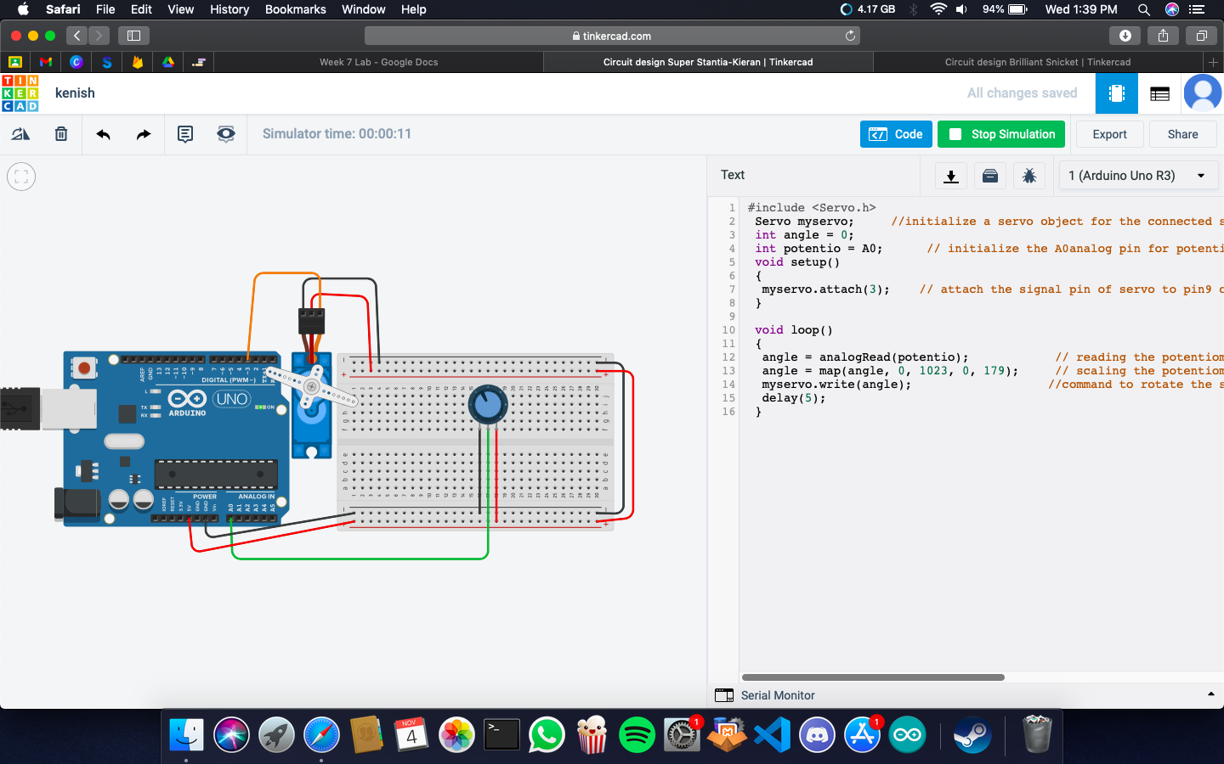

CODE:

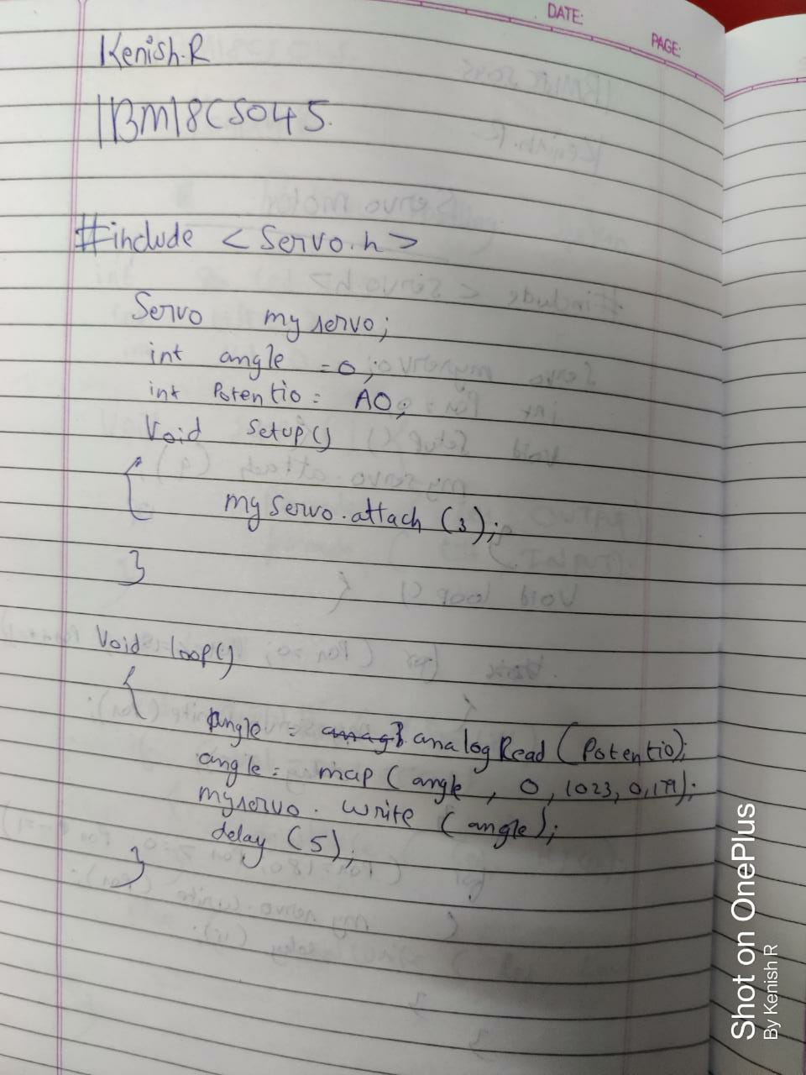

**Observation /Output**

**Servo meter will rotate.**